Lesson 15: Health- Shxwíyolem
sqwal
slexwíws | *** | whole body
sqw'éméls | *** | forehead
tépsem | *** | back of head, back of the neck
s'ó:thes | s'ólethes | face
thó:mél | themthó:mél | eyebrow(s)
shxw'íle | shxw'el'íle | cheek(s)
schelhó:ythel | *** | upper lip
stl'epó:ythel | *** | lower lip
yél:és | *** | tooth/teeth
téxwthelh | texwtéxwthelh | tongue
ts'emxó:ythel | ts'emts'emxó:ythel | jaw, chin
sqelxwále | sqelqelxwá:lá | throat
shx̲w'éllhelh | *** | front of the neck
shxw'í:lá:má:lá | shxwel’xwel’í:lá:má:lá | shoulder(s)
kweq'tál | kwokwéq'tel | shoulder blade(s)
t'lhí:léstel | *** | collar bone

sqwéltel
alétse kw'es e x̲ex̲élh? | where is it hurting?
x̲ex̲élh tel stl'epó:ythel | my lower lip really hurts.
sáyem tel stl'epó:ythel. | my lower lip aches.
lí ew lí kw'e éw x̲ex̲élh? | do you have any other pain?
x̲ex̲élh tel shxw'el'íle. | my cheeks hurt.
xwe’ít thútl’ó? | what is the matter with her?
xwel x̲ex̲élh te schelhó:ythels. | her upper lip still hurts.
x̲ex̲élh te kwokwéq'tels. | her shoulder blades hurt.
alétse kw'a x̲ex̲élhélep | where are you guys hurting?
x̲ex̲élh te tépsemtset. | our necks hurt.
x̲ex̲élh te thó:méltset. | our eyebrows hurt.
xwe’ít yutl’ólem? | what is the matter with them?
li xwel x̲ex̲élh te s'ó:thes? | does their face still hurt?
xwel x̲ex̲élh te téxwthelhs. | their foreheads still hurt.
xwel x̲ex̲élh te shxwel’xwel’í:lá:má:lás. | their shoulders hurt.
ílhchap selchím kwá tlówáyel? | how were you folks doing today?
tset tu éyó tlowáyel. | we’re doing well today.
éwetset it tu éyó tlówáyel. | we’re not doing too well today.
lí x̲ex̲elh ta' qél:ém? | is your eye hurting?
me éyéyel tel qé:lém. | my eyes got better.

The word x̲ex̲élh uses the possessive paradigm, “my x hurts”

iaqtem te sqwal
x̲ex̲élh hurt
intransitive /possessive | singular | plural
1st person (I / we) | x̲ex̲élh tel sqelxwále | x̲ex̲élh te sqelxwáletset
2nd person (you / y'all) | x̲ex̲élh ta’ sqelxwále | x̲ex̲élh te sqelxwálechap
3rd person (she, he, it / they) | x̲ex̲élh te sqelxwáles | x̲ex̲élh te sqelxwáles

Halq’eméylem 2, S’íwes 15 tel skwix
Sqwal 1 swáyel

íwesa:ls: The children got into a bee’s nest and got stung. K’halsetenmo:t and Tata are helping them. With your partner, re-enact their conversation. Follow the model.
 Máli example 1: K: áletse kw’s x̲ex̲élhs the Máli?
T: x̲ex̲élh te kweq'táls.

Sapát qes Kweto:liya example 2: K: áletse kw’s x̲ex̲élhs te Sapát qes the Kweto:liya?
T: x̲ex̲élh te s'ólethes
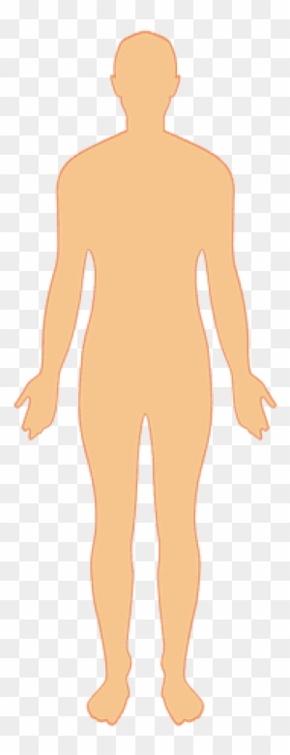 | slexwíws |  | 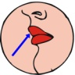 | schelhó:ythel |  |  | sqelxwále
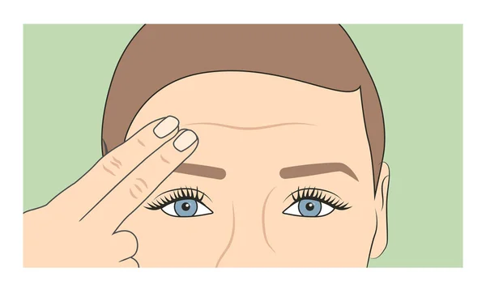 | sqw'éméls |  | 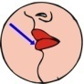 | stl'epó:ythel |  |  | sqelxwále
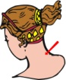 | tépsem |  |  | yél:és |  |  | shxw'í:lá:má:lá
 | s'ó:thes |  |  | téxwthelh |  | 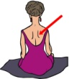 | kweq'tál
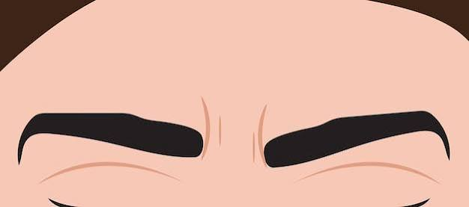 | thó:mél |  |  | ts'emxó:ythel |  | 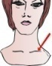 | t'lhí:léstel
 |  |  |  | shxw'íle

1. | 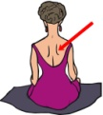 |  | 2. |  |  | 3.
 | Malí |  |  | Poleqtenót |  |  | Semeonsia qas Koyalemot
4. |  |  | 5. |  |  | 6. | 
 | Sólya qes Kweto:liya |  |  | Siqwamíya |  |  | Stípl
7. | 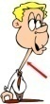 |  | 8. |  |  | 9. | 
 | Chól |  |  | Peth |  |  | Teqwótenot qas Peth
Halq’eméylem2, S’íwes 15 skwix
vocabulary 2 swáyel

Instructions You and your partner are sick and miserable. Take turns asking each other what is the matter. Follow the model.

example 1: A: lí chexw we éyo tl'ówayel?
C: x̲ex̲élh tel stl'epó:ythel

A |  |  |  | C
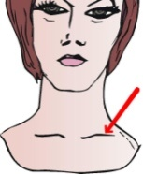
t'lhí:léstel |  | slexwíws |  | tépsem |  | s'ó:thes
 | 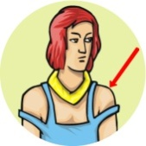
 | shxw'í:lá:má:lá |  |  |  | thó:mél
 |  |  |  |  |  | 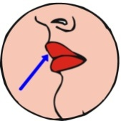
sqw'éméls |  | ts'emxó:ythel |  | shxw'íle |  | schelhó:ythel
 | 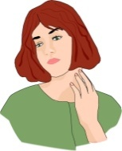 |  |  |  | 
 | sqelxwále |  |  |  | téxwthelh
 |  |  |  |  |  | 
stl'epó:ythel |  |  |  |  |  | yél:és

Halq’eméylem2, S’íwes 15 tel skwix
grammar 1 swáyel

Instructions With your partner, re-enact the conversations that took place at the clinic. Follow the model.

teléwe example 1: A xwe’ítchexw?
C: x̲ex̲élh tel kweq'tál

teléwe qes Siqwámiya example 2: A: xwe’ítchap teléwe qes te Siqwámiya?
C: x̲ex̲élh te s'ólethes.

(remember to use the plural form where appropriate!)
 | slexwíws |  |  | schelhó:ythel |  |  | sqelxwále
 | sqw'éméls |  |  | stl'epó:ythel |  |  | sqelxwále
 | tépsem |  |  | yél:és |  |  | shxw'í:lá:má:lá
 | s'ó:thes |  |  | téxwthelh |  |  | kweq'tál
 | thó:mél |  |  | ts'emxó:ythel |  |  | t'lhí:léstel
 |  |  |  | shxw'íle

1. | 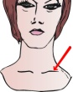 |  | 2. |  |  | 3.
 | telewe |  |  | telewe qas Tata |  |  | peth qas Susal
4. |  |  | 5. | 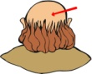 |  | 6.
 | telewe qas swólesíya |  |  | telewe |  |  | telewe qas típet
7. |  |  | 8. |  |  | 9. | 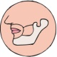
 | telewe |  |  | solya qas Maexetel |  |  | Poleqtenót

Halqeméylem 2, S’íwes 15 Skwix
Qwulqweltel swáyel

Listen to, Read and Translate the dialoge with a partner. Re-enact and then switch roles.

A: éy swáyel
B éy swáyel. Temtám kw'es iyólems kw'els kw'átset te tókte?
A Chexw kwá selchím tlóqá:ys?
B x̲ex̲élh tel tépsem
A Lí ō lí te qelát x̲ex̲élh?
B Á:'a, ew xwel x̲ex̲élh tel sqelxwále.
A Lúlh selchím kw'és híths kw'ses sáyem ta' sqelxwále?
B Lúlh lá th'ó:kws swáyel. Éwe lis éy. El stl'í kw'els kw'étslexw te tókte tl'ówáyél.
A Skw'áy kw'as kw'étslexw te tókte láme kw'e stú:xws wáyeles.
B: Tl'ócha éy. Kw'étslóme wáyeles.
A: Kw'étslómecha wáyeles.

Translation

When would it be okay for me to see the doctor?
How are you feeling now?
My neck is hurting.
Do you have anything else hurting?
Yes, my throat is still sore too.
How long has your throat been hurting?
For seven days. It’s not good. I would like to see the doctor today.
You can’t see the doctor until 9 tomorrow
That will be good. See you tomorrow.

Halq’eméylem 2, 15 Skwix
Grammar worksheets Swayel

A: use the appropriate form of “it hurts” in the phrases below. Then translate the whole sentence into English.

- _________ x̲ex̲élh tel yél:és. (it hurts me)
Xwelítemqel: my tooth hurts.

- _____ x̲ex̲élh te sqelqelxwá:látset. (it hurts us)
Xwelítemqel: our stomach hurts since yesterday

- Chexw tsélq qas x̲ex̲élh ta’ texwtéxwthelh. (it hurts you)
Xwelítemqel: you fell down and your tongue hurts.

- x̲ex̲élh ____te tépsemchap yilaw íwólem te hélme'als po:l (it hurts y’all)
Xwelítemqel: y’all have a sore neck after playing soccer

- X̲ex̲élh te yél:és qas the shxw'íles. (it hurts her)
Xwelítemqel: Her tooth hurts, and her cheek too

- ts’atsel qwóqweltel,____ x̲ex̲élh _____ye texwtéxwthelhs tloqays. (it hurts them)
Xwelítemqel: they talked too much, now their tongues hurt.

- ___________xexélhtel_tel slexwíws. (it hurts me)
Xwelítemqel: my body hurts

- li _chap_xexélh ___te schelhó:ythel? (it hurts y’all)
Xwelítemqel: does (y’all’s) upper lip hurt?

- ____Xexélh ___te sqw'éméles tútl’ó. (it hurts him)
Xwelítemqel: his forehead hurts

- Íyó:tel yutl’ólem,____xexélh ____te s'ólethes tl’óqays. (it hurts them)
Xwelítemqel: they were all in a big fight, their faces hurts now

the -s for third person blends with the s from s'ólethes

